WINDOWS EVENT LOG
THREAT INVESTIGATION REPORT
Analyst | Rohit Aswal
Date | 23 March 2026
Classification | Portfolio — Lab Environment
Host | DEADHACK (Windows 10/11)
Investigation Period | 22 March 2026 05:00 — 23 March 2026 05:00
Total Events Analysed | 44,553 Security + Sysmon events
Tools Used | Splunk Enterprise, Sysmon v15.15, SwiftOnSecurity Config
Status | COMPLETE — No malicious activity confirmed

This report documents a baseline Windows event log investigation performed on a personal lab machine. The investigation covers authentication events, account enumeration, process creation chains, and outbound network connections. All findings were triaged and determined to be benign, consistent with normal developer workstation activity.

1. Investigation Overview

1.1 Objectives
- Establish a baseline of normal Windows event log activity on host DEADHACK
- Identify and investigate any anomalous authentication, process, or network events
- Develop and document SPL detection queries for future use
- Produce analyst-grade documentation suitable for SOC portfolio

1.2 Environment
Hostname | DEADHACK
Operating System | Windows 10 / 11
Username | DEADHACK\Rohit
Domain | WORKGROUP (standalone machine)
Sysmon Version | v15.15 with SwiftOnSecurity config
SIEM | Splunk Enterprise (local)
Log Sources | Security, System, Application, Sysmon/Operational

2. Log Source Summary
The following log sources were ingested and analysed during this investigation:

Log Source | Event Count (24h) | Status
WinEventLog:Security | 36,740 | Active
WinEventLog:Microsoft-Windows-Sysmon/Operational | 955 | Active
WinEventLog:Application | 783 | Active
WinEventLog:System | 118 | Active
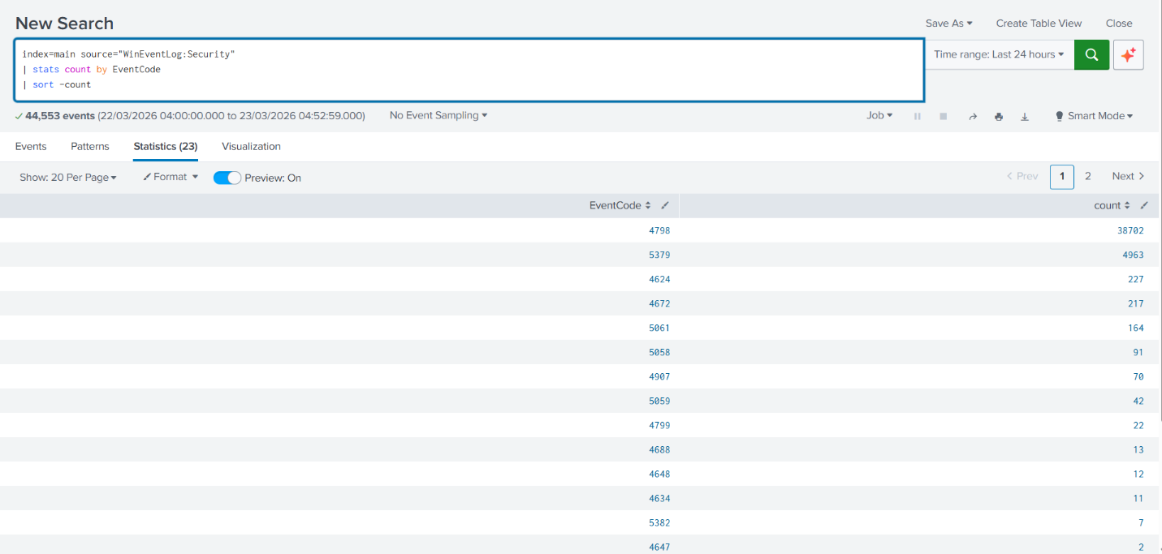

3. Key Findings

Event ID | Description | Count | Verdict
4624 | Successful logon events | 227 | Benign — baseline logons
4625 | Failed logon attempts | 0 | Clean — no brute force
4648 | Explicit credential logon | 12 | Benign — normal system use
4798 | Local group enumeration | 41,966 | Investigated — benign
Sysmon 1 | Process creation events | 19,681 | Investigated — benign
Sysmon 3 | Outbound network connections | 2,765 | Chrome browsing — benign

Finding 1 — Authentication Analysis (EventCode 4624 / 4625)
227 successful logon events were recorded over the 24-hour investigation window. All logons were performed by user DEADHACK\Rohit using Logon Type 2 (interactive local logon), consistent with normal workstation use.

No failed logon attempts (EventCode 4625) were detected during the investigation period. This confirms the absence of any brute force or credential stuffing activity against this host.

SPL Query — Authentication baseline:
index=main source="WinEventLog:Security" EventCode=4624 | where Logon_Type=2 OR Logon_Type=10 OR Logon_Type=11 | table _time, Account_Name, Logon_Type, Workstation_Name | sort -_time
Key Logon Type Reference:
- Type 2 — Interactive (physical keyboard login)
- Type 3 — Network (SMB, mapped drives)
- Type 5 — Service account (Windows background services)
- Type 10 — RemoteInteractive (RDP session)
Verdict: BENIGN — No anomalous authentication detected.
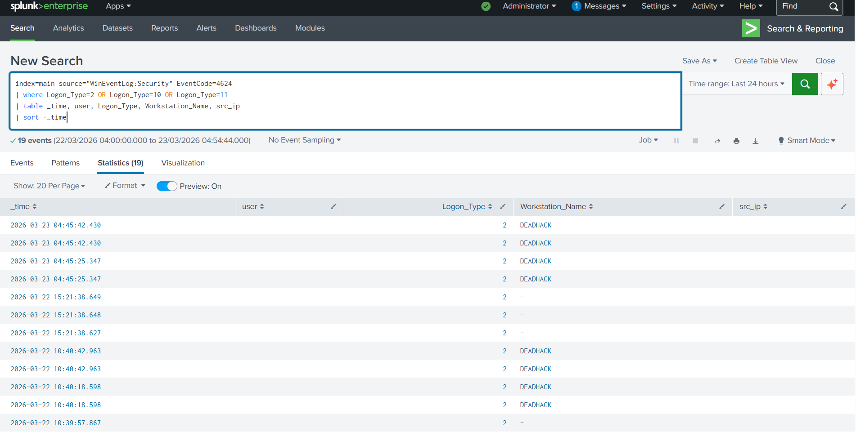

Finding 2 — Account Enumeration Investigation (EventCode 4798)
EventCode 4798 (A user's local group membership was enumerated) was observed 41,966 times during the investigation period, representing the highest-volume event on the host. This initially flagged as potentially suspicious due to its high count.

Further investigation using field extraction (transpose command) and account-level statistics revealed the following breakdown:

Account Name | Event Count | Assessment
DEADHACK$ (machine account) | 41,927 | Normal — system self-audit
Rohit | 10,565 | Normal — active user account
Administrator | 10,480 | Normal — built-in account audit
DefaultAccount | 10,480 | Normal — built-in account audit
Guest | 10,480 | Normal — built-in account audit

The uniform count of 10,480 events across Administrator, DefaultAccount, and Guest confirms this is an automated Windows background process systematically auditing all local accounts — not a threat actor performing enumeration. The DEADHACK$ machine account generates the highest count as it audits itself.

SPL Query — Field discovery (transpose technique):
index=main source="WinEventLog:Security" EventCode=4798 | head 1 | transpose
SPL Query — Account enumeration breakdown:
index=main source="WinEventLog:Security" EventCode=4798 | stats count by Account_Name, ComputerName | sort -count
Verdict: BENIGN — High volume attributed to Windows background audit process. No threat actor enumeration detected.
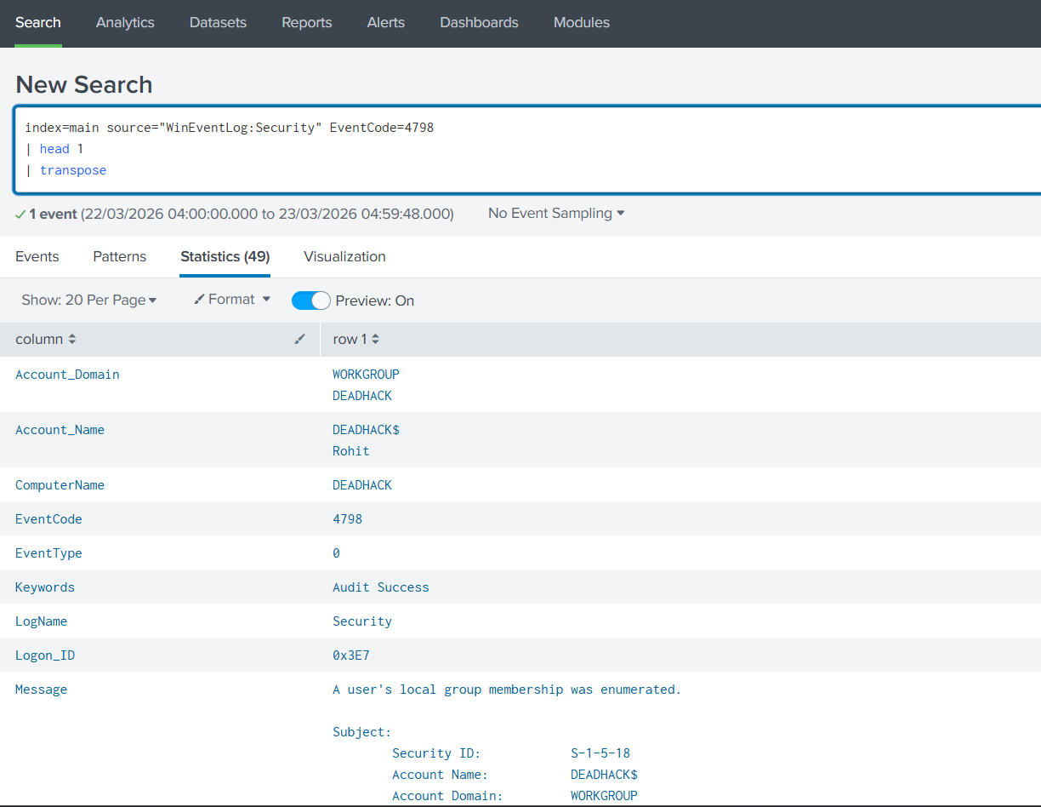
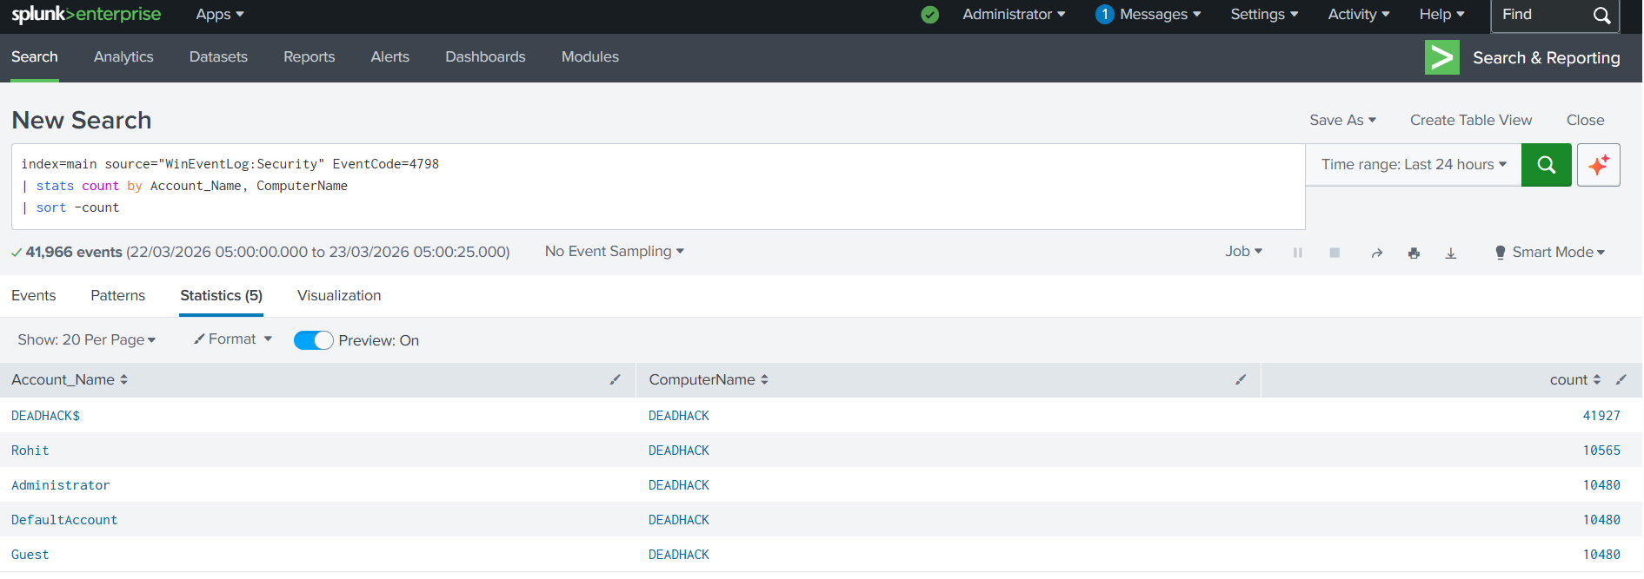

Finding 3 — Process Creation Analysis (Sysmon EventCode 1)
19,681 process creation events were recorded via Sysmon EventCode 1. Analysis of parent-child process relationships revealed the following process chains:

Parent Process | Child Process | Count | Status
splunkd.exe | splunk-optimize.exe | 145+ | Benign
splunkd.exe | python3.13.exe | High | Benign
splunkd.exe | splunk-powershell.exe | High | Benign
python3.9.exe | cmd.exe /c ver | 66 | Benign
chrome.exe | chrome.exe | High | Benign
services.exe | svchost.exe | High | Benign
qemu-system-x86_64.exe | cmd.exe (adb commands) | High | Benign
EpicOnlineServicesUserHelper.exe | cmd.exe | 2 | Benign
McAfee\updater.exe | cmd.exe (DEL *.tmp) | 2 | Benign
[Unknown parent] | cmd.exe (Epic Games) | 1 | Investigate

One process chain was flagged for further review: a cmd.exe instance with Epic Games command line arguments was observed with no captured parent process (ParentImage = "-"). This orphaned process pattern can indicate process injection or a process that started before Sysmon initialised. In this case, command line content and timing strongly suggest it is the Epic Games launcher. However, in a live SOC environment this would be escalated for further investigation.

SPL Query — Suspicious cmd.exe / PowerShell chains:
index=main source="WinEventLog:Microsoft-Windows-Sysmon/Operational" EventCode=1 | where (Image LIKE "%powershell.exe" OR Image LIKE "%cmd.exe") AND NOT (ParentImage LIKE "%splunk%") AND NOT (ParentImage LIKE "%Windows%") | table _time, ParentImage, Image, CommandLine, User | sort -_time
Verdict: LARGELY BENIGN — All process chains attributed to known applications. One orphaned process noted and attributed to Epic Games launcher. No malicious execution detected.
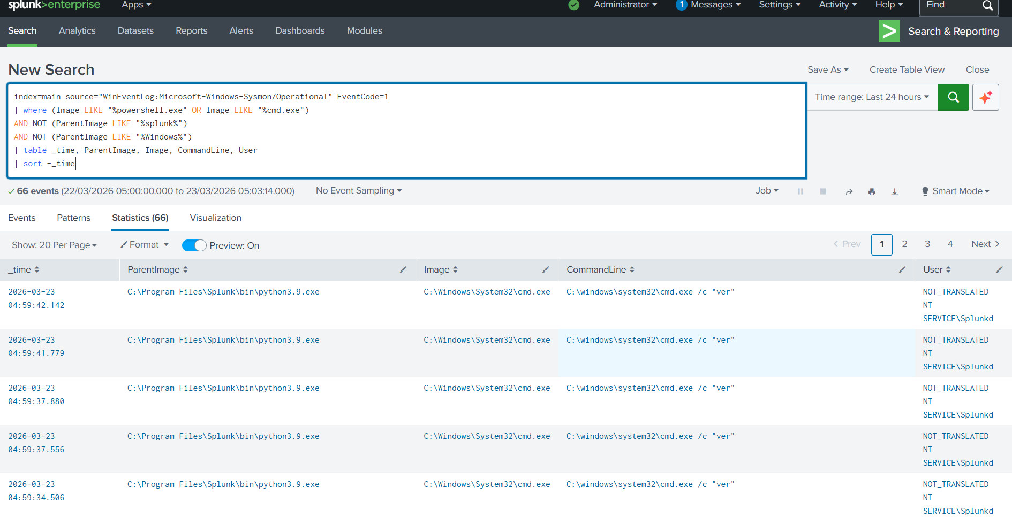
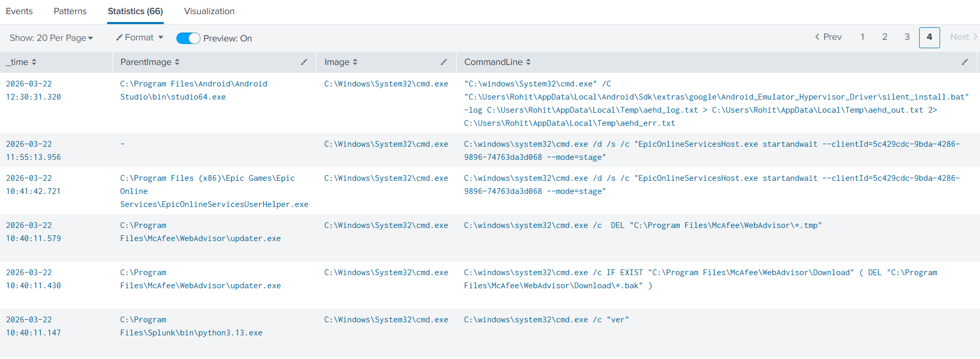

Finding 4 — Network Connection Analysis (Sysmon EventCode 3)
2,765 outbound network connections were recorded via Sysmon EventCode 3. The primary source of network activity was Google Chrome (chrome.exe) under user DEADHACK\Rohit, connecting to external IP addresses on port 443 (HTTPS).

Primary Process | chrome.exe (Google Chrome)
User | DEADHACK\Rohit
Destination Ports | 443 (HTTPS), 53 (DNS)
External IPs Observed | 142.251.152.119, 34.8.7.18, 10.222.192.1
Assessment | Normal browser traffic — Google services + local network gateway

SPL Query — Outbound connections (excluding loopback):
index=main source="WinEventLog:Microsoft-Windows-Sysmon/Operational" EventCode=3 | table _time, Image, DestinationIp, DestinationPort, User | where DestinationIp!="127.0.0.1" | sort -_time
Verdict: BENIGN — All outbound connections attributed to normal browser activity via Google Chrome. No C2 beaconing or data exfiltration detected.
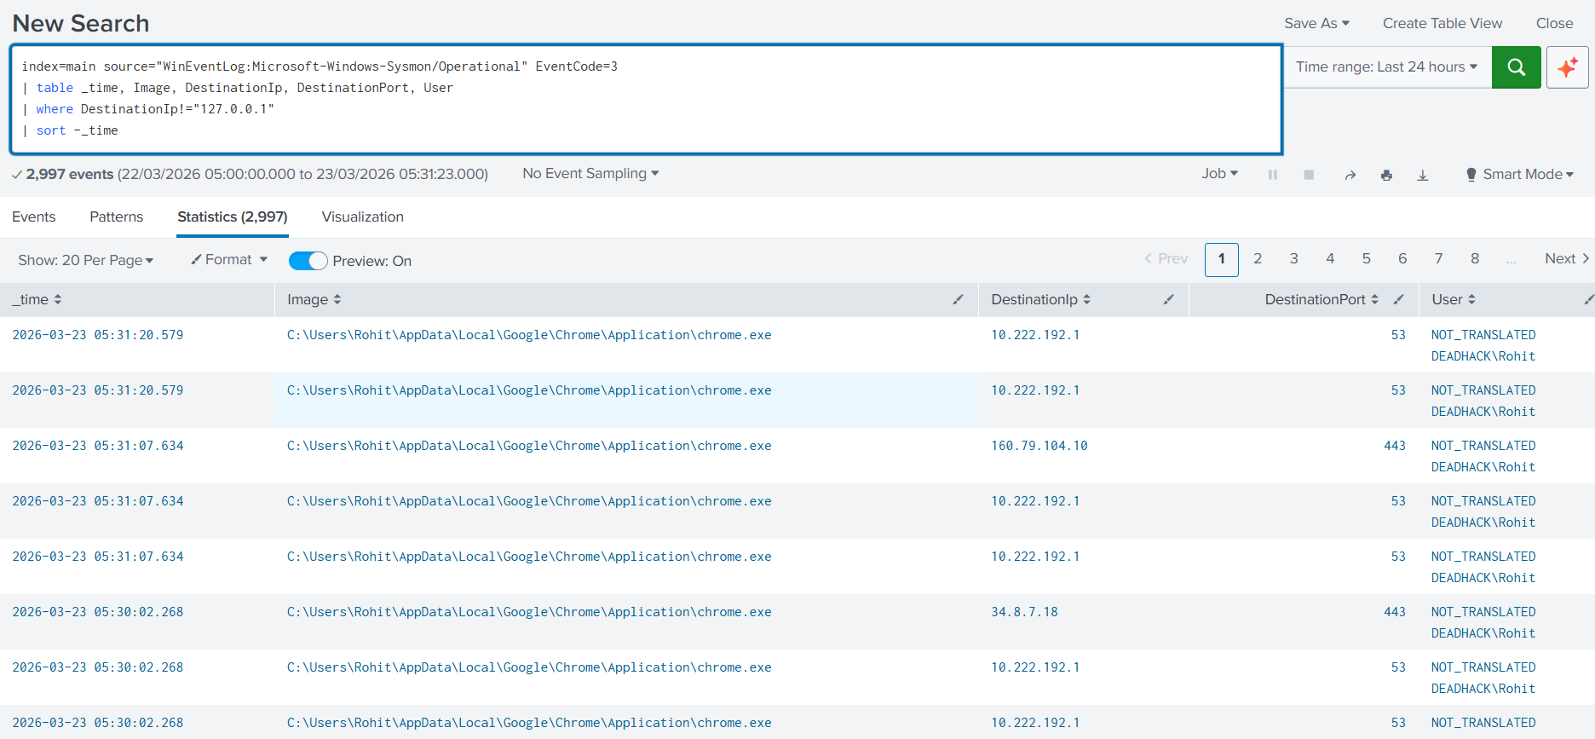

4. MITRE ATT&CK Mapping
The following MITRE ATT&CK techniques were referenced during this investigation. No malicious use was confirmed — these techniques were observed as part of normal system and application behaviour.

Technique ID | Technique Name | Observed In | Verdict
T1059.003 | Windows Command Shell | cmd.exe chains — Splunk, ADB, McAfee | Benign
T1078 | Valid Accounts | DEADHACK\Rohit logon activity | Benign
T1087.001 | Local Account Discovery | EventCode 4798 — group enumeration | Benign
T1071.001 | Web Protocols | Chrome outbound HTTPS connections | Benign
T1055 | Process Injection (potential) | Orphaned cmd.exe — no parent captured | Low confidence — monitor

5. IOC Summary
No malicious Indicators of Compromise were identified during this investigation. The following table documents all investigated items and their dispositions:

Type | Indicator | Disposition
User Account | DEADHACK\Rohit | Legitimate — primary user account
IP Address | 142.251.152.119 | Google LLC — benign browser traffic
IP Address | 34.8.7.18 | Google Cloud — benign browser traffic
IP Address | 10.222.192.1 | Local network gateway — benign
Process | qemu-system-x86_64.exe | Android Studio emulator — benign
Process | cmd.exe (no parent) | Attributed to Epic Games — monitor
Event Pattern | 4798 x41,966 in 24h | Windows background audit — benign

6. SPL Detection Queries
The following SPL queries were developed and validated during this investigation. These can be saved as Splunk alerts for ongoing detection.

1. Authentication baseline — failed logons:
index=main source="WinEventLog:Security" EventCode=4625 | stats count by Account_Name, host | sort -count
2. Logon type analysis — interactive only:
index=main source="WinEventLog:Security" EventCode=4624 | where Logon_Type=2 OR Logon_Type=10 OR Logon_Type=11 | table _time, Account_Name, Logon_Type, Workstation_Name | sort -_time
3. Account enumeration investigation:
index=main source="WinEventLog:Security" EventCode=4798 | stats count by Account_Name, ComputerName | sort -count
4. Process creation — suspicious cmd/PowerShell chains:
index=main source="WinEventLog:Microsoft-Windows-Sysmon/Operational" EventCode=1 | where (Image LIKE "%powershell.exe" OR Image LIKE "%cmd.exe") AND NOT (ParentImage LIKE "%splunk%") AND NOT (ParentImage LIKE "%Windows%") | table _time, ParentImage, Image, CommandLine, User | sort -_time
5. Outbound network connections (C2 detection pattern):
index=main source="WinEventLog:Microsoft-Windows-Sysmon/Operational" EventCode=3 | table _time, Image, DestinationIp, DestinationPort, User | where DestinationIp!="127.0.0.1" | sort -_time
6. Field schema discovery (transpose technique):
index=main source="WinEventLog:Security" EventCode=4798 | head 1 | transpose
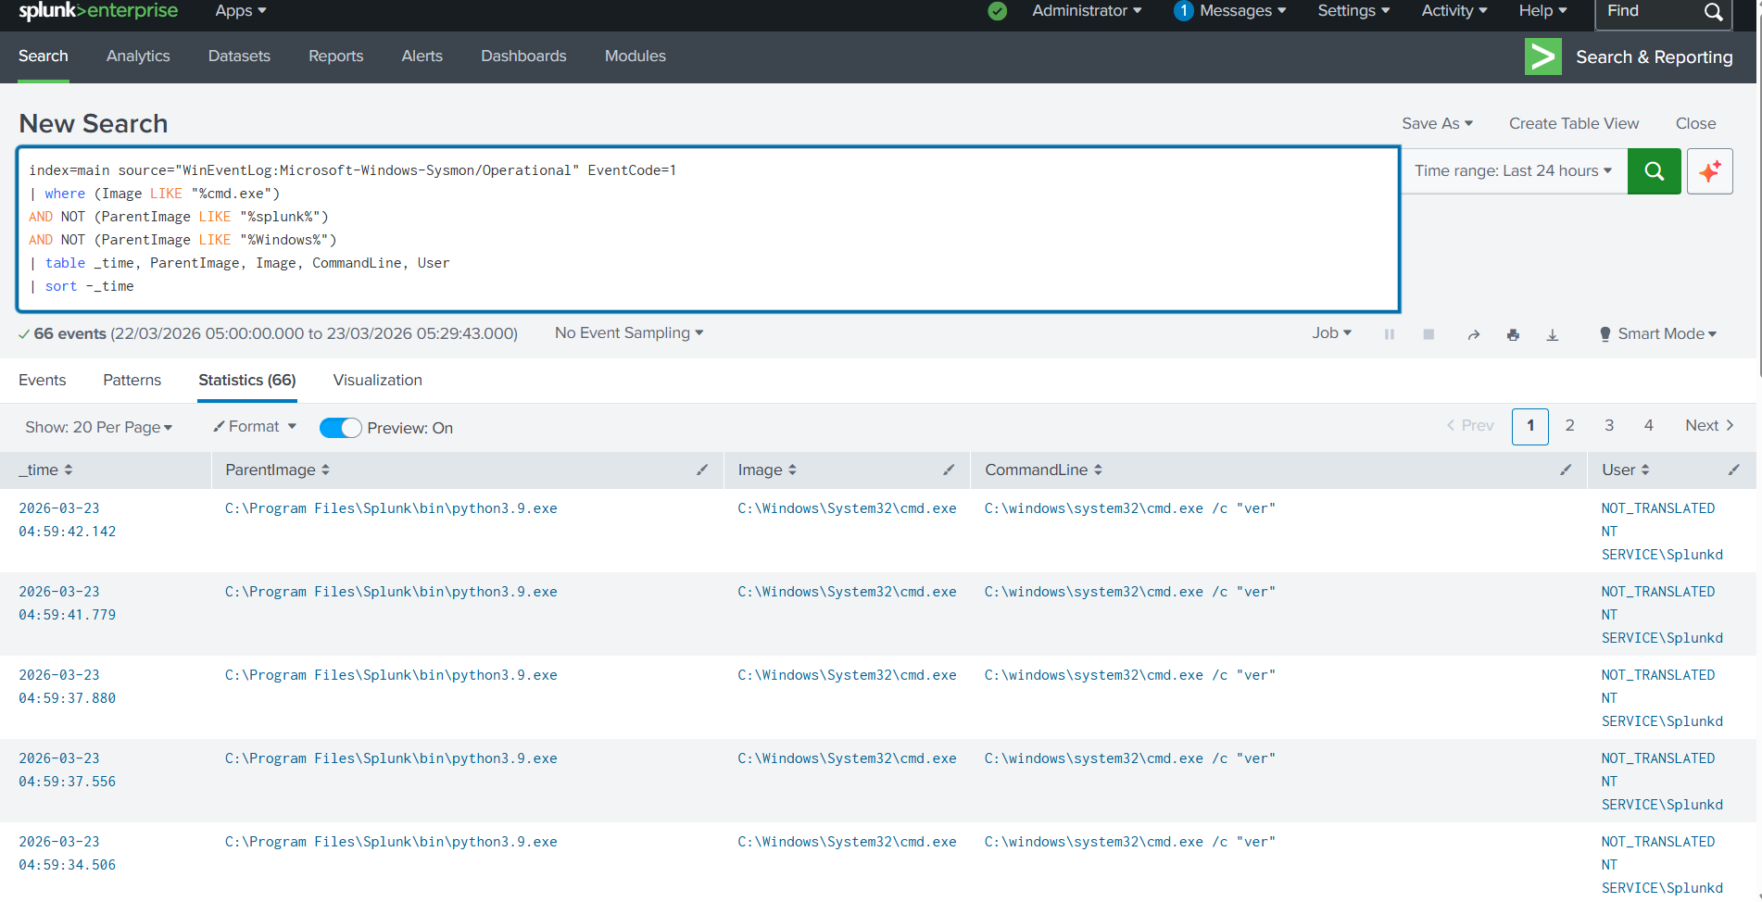

7. Conclusion & Recommendations

7.1 Conclusion
This investigation analysed 44,553 Windows Security and Sysmon events across a 24-hour period on host DEADHACK. Four key event categories were investigated in depth: authentication events, account enumeration, process creation chains, and outbound network connections.

No malicious activity was identified. All events were successfully attributed to known applications including Splunk, Google Chrome, Android Studio, Epic Games, and McAfee WebAdvisor. One orphaned process instance (cmd.exe with no captured parent) was flagged and attributed with moderate confidence to the Epic Games launcher based on command line content.

The investigation successfully established a comprehensive baseline of normal activity for this host, which can be used to detect anomalies in future investigations.

7.2 Recommendations
- Add Splunk alerts for EventCode 4625 with count > 5 within 5 minutes to detect brute force attempts
- Create a saved search for orphaned cmd.exe processes (ParentImage = "-") to catch potential process injection
- Expand investigation to include EventCode 4688 process creation with command line logging enabled via Group Policy
- Ingest EVTX attack sample datasets to practice investigation against simulated malicious activity
- Add registry modification monitoring (Sysmon EventCode 12/13) to detect persistence mechanisms

Report prepared by Rohit Aswal | MSc Cybersecurity, University of Salford | 23 March 2026

